**EXPERIMENT-08**

**AIM-**To develop PLC Ladder Program using counrter and compare instructions.

**EXERCISE**-

1) A stacking and bending system requires a spacer to be inserted in a stack of panel after 14 sheets are stacked. After 14 more (total 28), the stack is to be bended. Assume suitable sensors and outputs to creats ladder diagram for this system. Listout inputs and outpits used clearly with their address.

Input: Proxy1 - I:0.0/2 Output:Spacer- O:0.0/0

Proxy2 - I:0.0/3 Bending – O:0.0/1

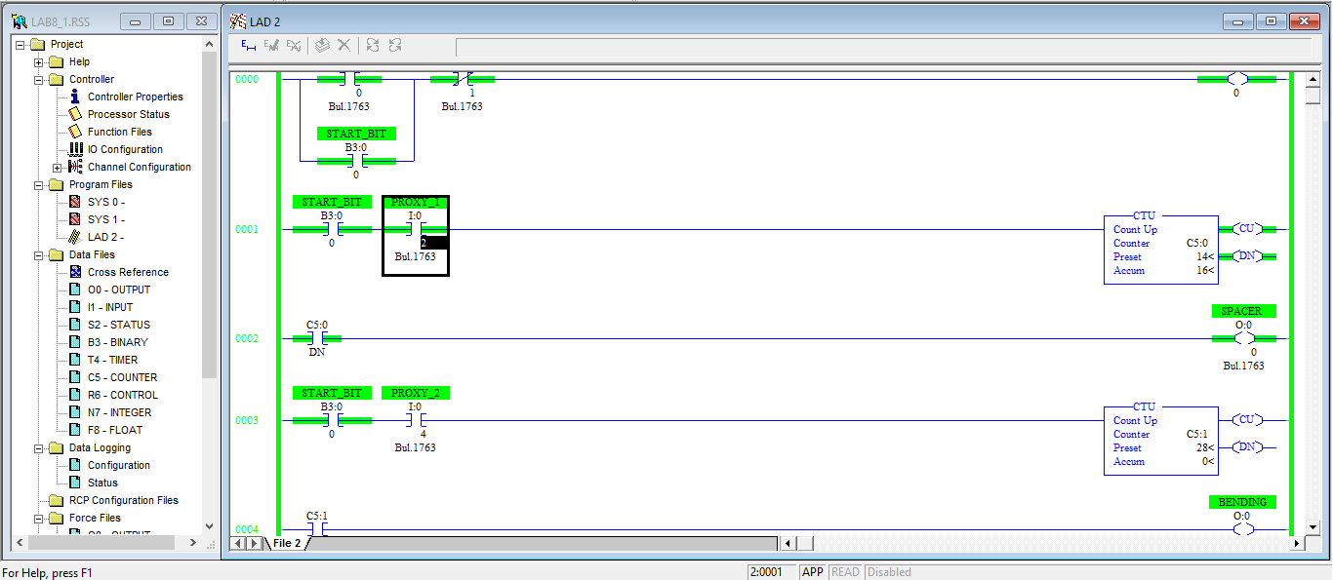

2)Following all the steps for ladder diagram construction, prepare PLC ladder diagram using RsLogix 500 software for following problem:

“A mixing systemcomprises of following sequence of operation: By pressing start button material A start for 5 min. After that material B starts for 6 min. Later on stirrer starts for 10 min. At the end drain valve opens for 3 min to empty the vessel. Counter counts the entire operation as 1 cycle ,after 4 such cycle system reset automatically. Write a program to control entire operation. System includes start,stop and emergency stop button.

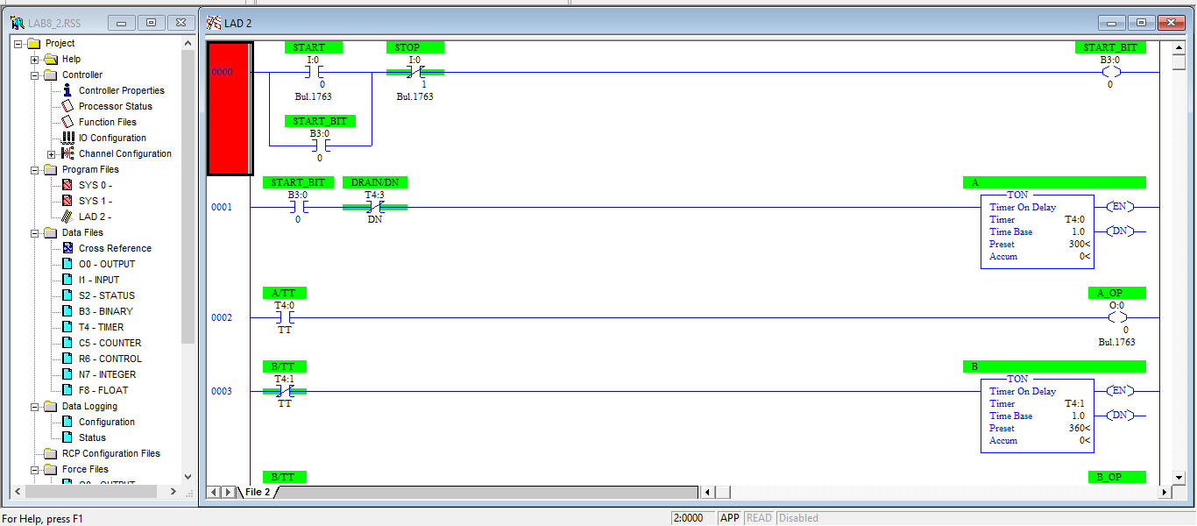

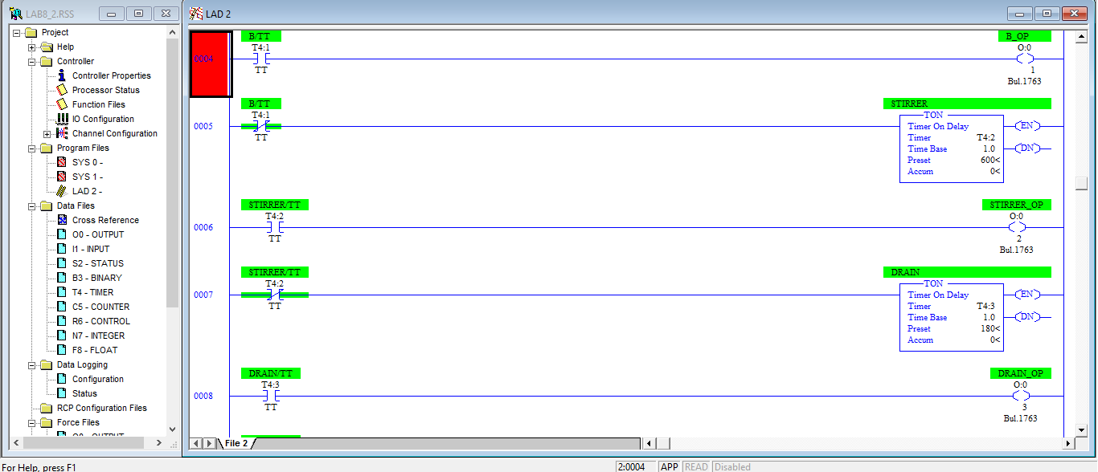

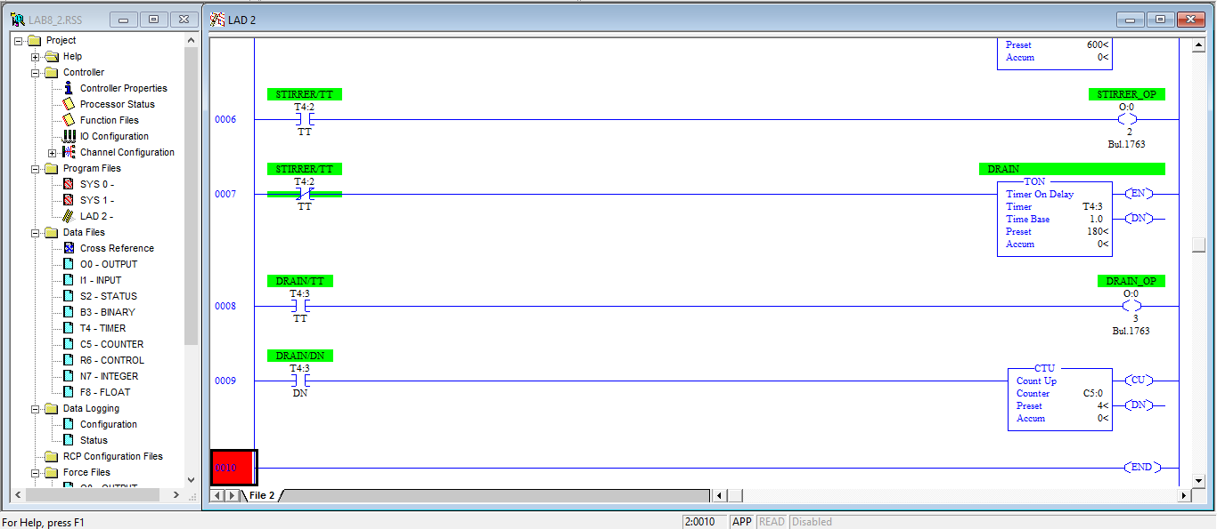

3) Following all the steps for ladder diagram construction, prepare PLC ladder diagram using RsLogix 500 software for following problem:

There are two conveyors each with sensors to count I/O parts entering and leaving the conveyor. There are to be 3 indicating lights as follows:

Number of parts on conveyors equals: white light

Number of parts on conveyors1 is greater:green light

Number of parts on conveyors2 is greater:blue light

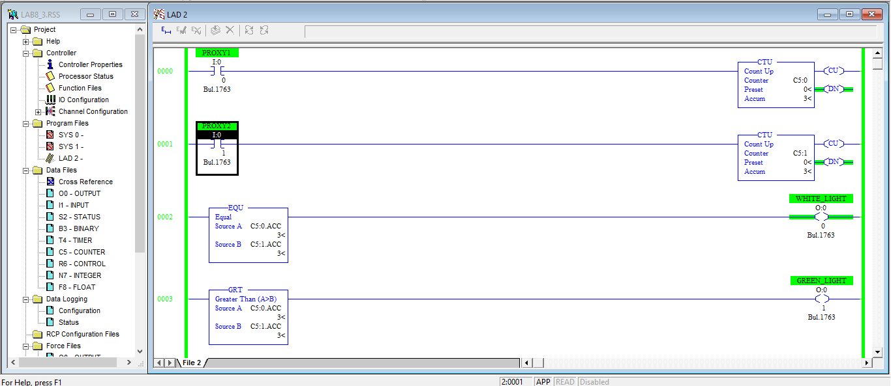

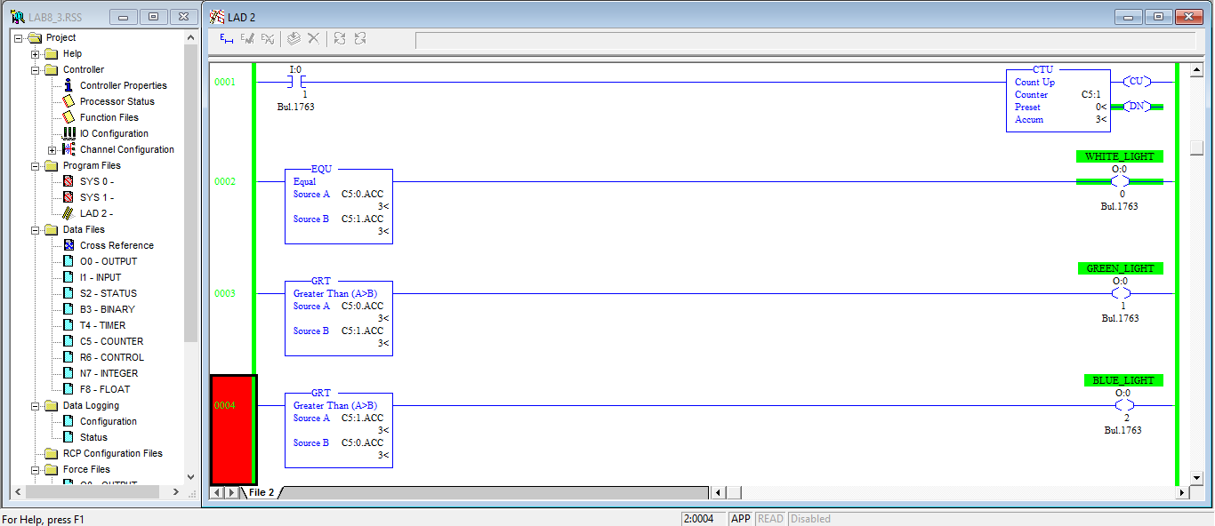

4)Using word comparision instruction develop a traffic light control program which operates as per given below scheme. To control start and stop use pushbuttons. List out all I/O used clearly with their addresses.

Input:Start - I:0.0/0 Output: Red - O:0.0/0 Green – O:0.0/2

Stop – I:0:0/1 Yellow – O:0.0/1

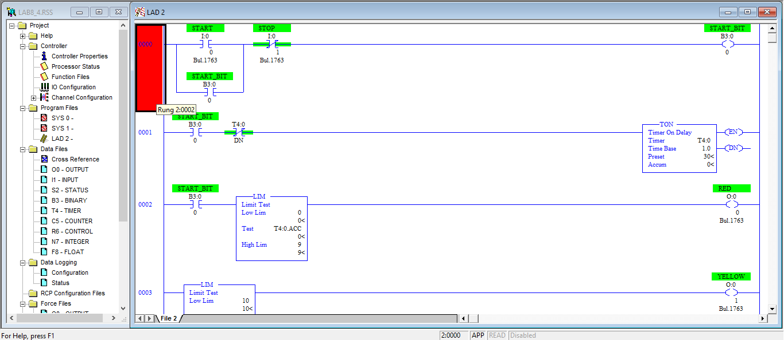

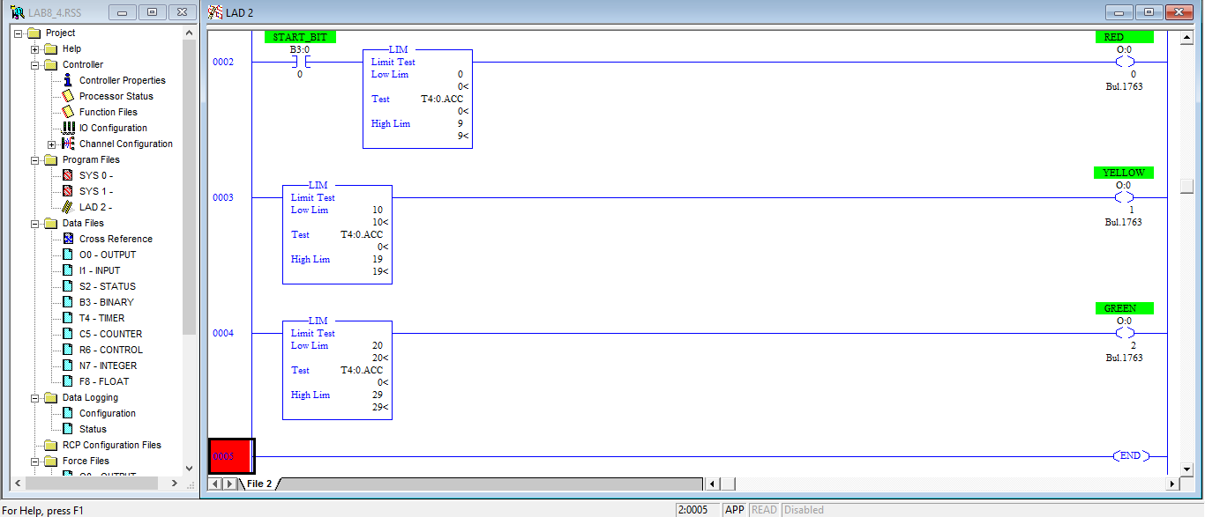

5)Using word comparison instruction, develop a traffic light control program which operates as per below given scheme:

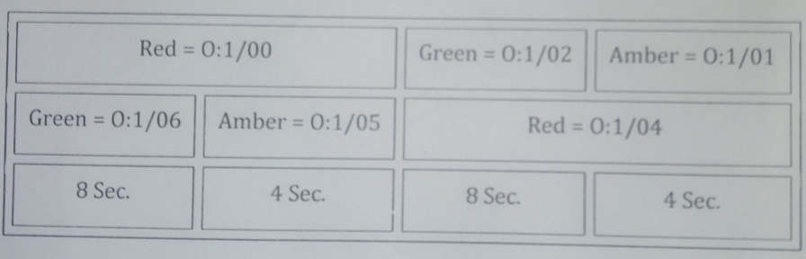

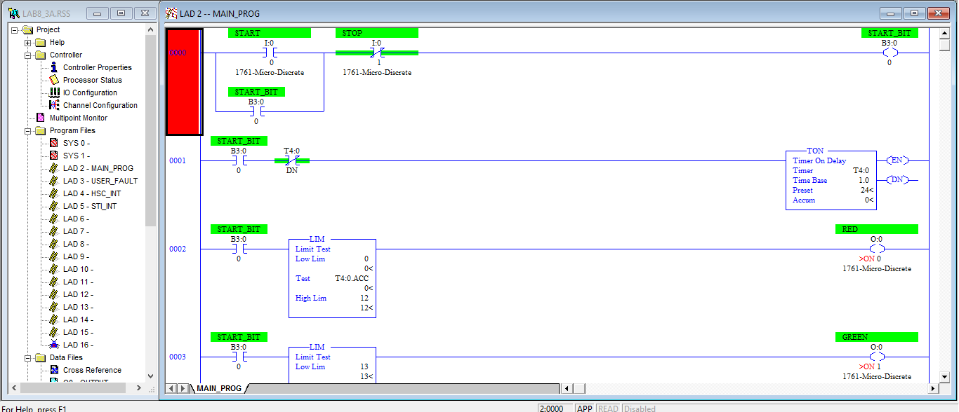

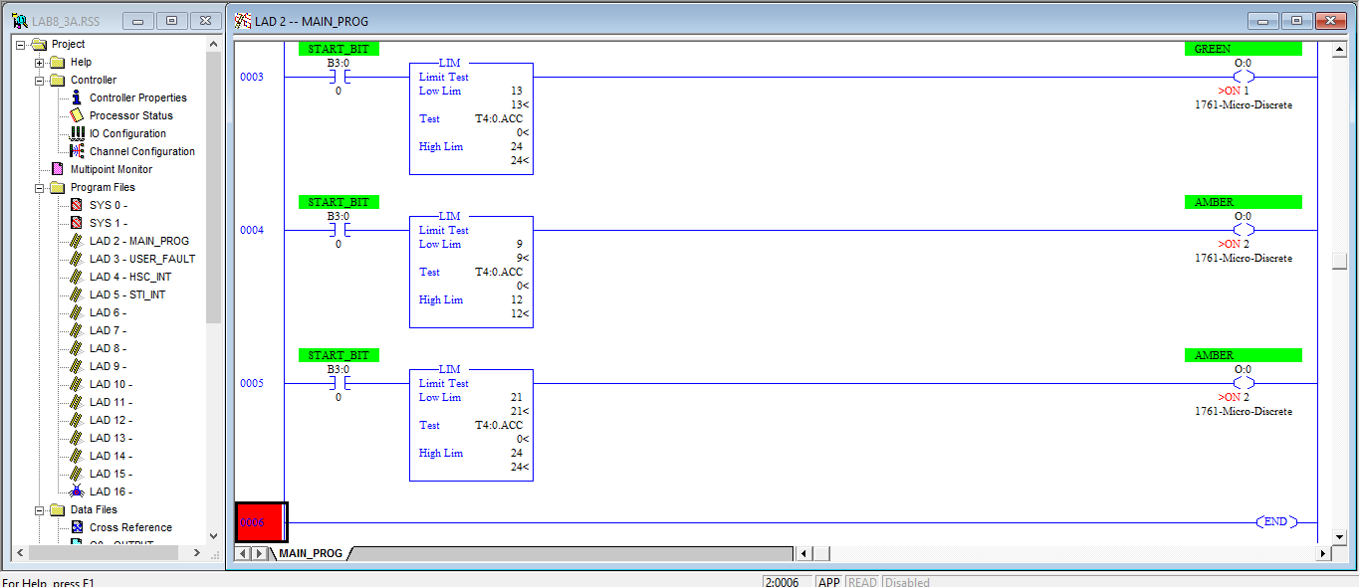

6) Motor M1 starts 10 sec after start switch is pressed, after 5 sec M2 goes OFF and M3 starts and remains ON for 15 sec and stop.Then cycle us repeated.

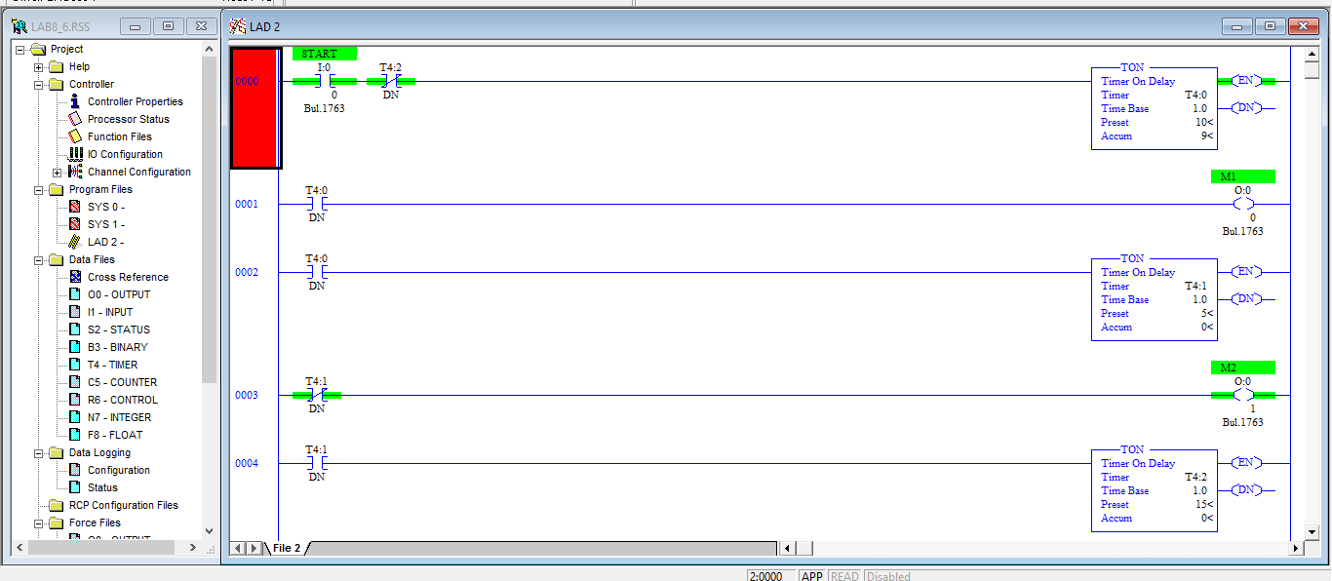

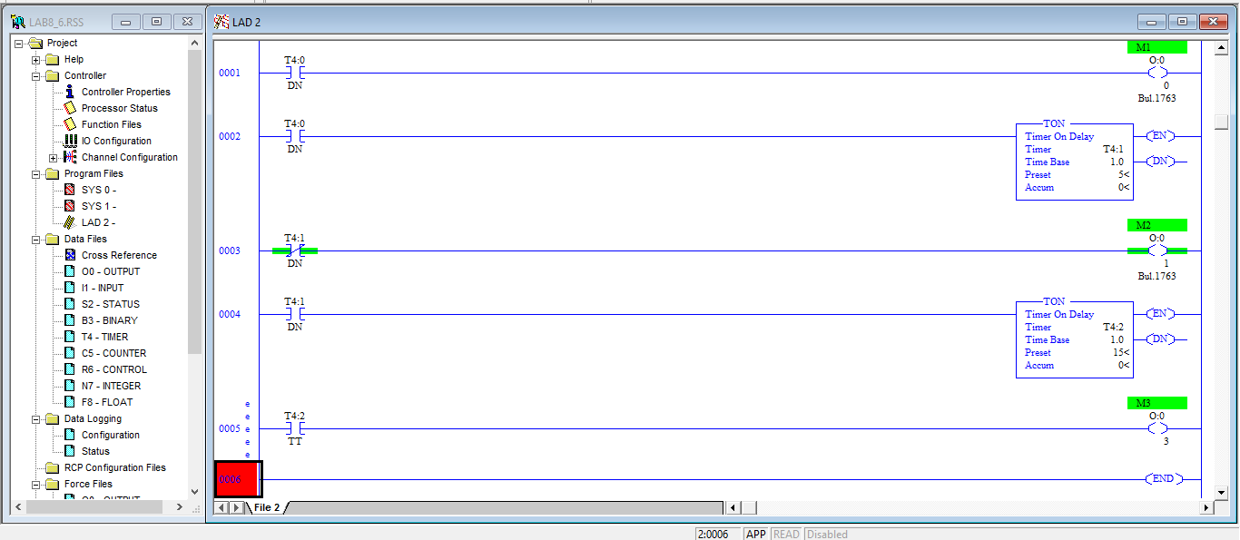

7)Draw ladder diagram for the problem given below:To generate a square wave having ON pulse timing as 10 sec. A counter counts no of pulses. The system restart whenever counts are 100000 or stop is pressed.List out all I/O used clearly,with their respective addresses.

Input:Start – I:0.0/0 Stop – I:0.0/1

Output – O:0.0/0

